Altai State University
Institute of Digital Technologies, Electronics and Physics
Department of Computing Technique and Electronics
XIII International Conference on High-performance computing systems and technologies in scientific research, automation of control and production (HPCST-2023)
FIRST ANNOUNCEMENT
of Theoretical and Practical Conference, 19-20 May 2023
Head organizer of the conference: Altai State University (ASU), Barnaul, Russia
Co-organizers:
- Association of Asian Universities
- MIREA – Russian Technological University, Moscow, Russia
- Lomonosov Moscow State University, Moscow, Russia
- Novosibirsk State Technical University, Novosibirsk, Russia
- Khristianovich Institute of Theoretical and Applied Mechanics, Siberian Branch of Russian Academy of Sciences, Novosibirsk, Russia
- Polzunov Altai State Technical University, Barnaul, Russia

Information sponsors of the conference:
- Monthly theoretical and applied scientific and technical journal “Information Technologies” (ISSN 1684-6400), Moscow, Russia
- Monthly theoretical and applied scientific and technical journal “Software Engineering” (ISSN 2220-3397), Moscow, Russia
- Monthly theoretical and applied scientific and technical journal “Mechatronics, Automation, Control” (ISSN 1684-6427), Moscow, Russia
- Engineering Center CTC "Inline Group" under the official distributor of Xilinx in Russia
Date and place of the conference:
The registration of attendees will start on May 19 at 8-00. The schedule and the list of rooms for attendee registration as well as for the plenary session and thematic workshops will be announced in the second information letter. The conference aims to provide practitioners and researchers with the opportunity to discuss in person various relevant topics of modern information science, computer science, and their applications. Round-table meetings will be also arranged.
Applications for participation and manuscripts are accepted until April 17, 2023 via e-mail: W_Jordan@mail.ru. Notification of acceptance (or non-acceptance) of the paper will be sent to the authors in the second information letter by e-mail before April 20, 2023. As the outcome of the conference, the papers selected for publication by the Program Committee will be included in the 1st issue of the “High-Performance Computing Systems and Technologies” journal of 2023 (Vol. 7, No. 1), indexed at the RSCI. The program of workshop meetings will be formed by May 16, 2023 (and by May 16, 2023 will be sent to the conference participants by e-mail).
Important note: As the outcome of the conference, it is planned to publish extended (and revised) versions of papers in English in the journal “Communications in Computer and Information Science (CCIS)” indexed in Scopus & WoS databases with Q4 quartile.
Volume "CCIS 1733" (revised selected papers) of 12th International Conference HPCST-2022 (Barnaul, Russia, May 20-21, 2022) is now available online and can be accessed at https://link.springer.com/book/10.1007/978-3-031-23744-7.
The main sessions (sections) of the conference are indicated below, some topics are highlighted in each one.
Sessions of the Conference “HPCST-2023”:
- Session“Multi-processor computing systems, multi-core processors and programmable logic structures, digital signal processing” (Session Committee Members: I.E. Tarasov, V.S. Titov, I.Sh. Kadyrov, S.P. Pronin, A.V. Kalachev).
The First Session is devoted to the development of the multi-processor computing systems and electronic equipment using digital signal processors, multi-core processors, FPGAs and includes the following topics:
- Architecture and design features of the multi-processor computing systems: the experience of their use in computational practice;
- Architecture and design features of the hardware on the basis of FPGA, signal (DSP) and multi-core processors: the experience of their use in computational practice;
- IP-cores for FPGA (interfaces, functional blocks, processor cores): experience with FPGA and DSP, multi-core processors in the learning process;
- The use of accelerators and unconventional architecture computers (GPU, FPGA, etc.) in high-performance computing;
- Processing and synthesis of signals (including radio and audio ranges): the system of encoding-decoding of signals, modulation-demodulation of signals and etc.
- Session “Parallel programming and computer simulation of processes and phenomena in natural science with using of parallel computing” (Session Committee Members: E.P. Shurina, A.G. Yakunin, E.N. Kruchkova, V.I. Jordan).
The Second Session is devoted to the development of parallel programming technologies using multiprocessor computer systems and their application in simulation tasks of complex technical systems and processes in the natural sciences. The workshop includes the following topics:
- Operating systems and environments, programming technologies, facilities and tools for the design, optimization and debugging parallel applications;
- Technologies of distributed processing and distributed computing using multiprocessor computer systems (multi-core workstations, personal supercomputers and cluster systems);
- GRID-technologies and GRID-systems, cloud computing and services, neuronal network technologies: the experience of their use in computing practice and learning process;
- Parallel methods in cryptography and information security: encryption algorithms and methods to ensure confidentiality and authenticity of information;
- Multi-scale predictive computer simulation in electronics, physics and chemistry of nanostructured materials and metamaterials using parallel computing (quantum mechanical calculations, thermodynamic methods of Monte Carlo and molecular dynamics to calculate the cluster structures and parallel algorithms for visualization, methods of virtual computer-aided design and modeling in biomedical engineering and et al.);
- High-performance simulation of chemical and physical processes: computational hydrodynamics and gas dynamics, nonlinear and fast processes of combustion and synthesis of materials, processes propagation of radio waves in spatially inhomogeneous media and et al.

- Session “Robotics, control automation, production automation and automation of scientific experiment” (Session Committee Members: N.B. Filimonov, V.S. Avramchuk, P.Yu. Gulyaev, V.N. Sedalishchev, V.A. Faerman)
The Third Session is devoted to the development and creation of intelligent measuring and robotics complexes used for the automation of technological processes and scientific experiment, the creation of problem-oriented intellectual research laboratories using ICT, multimedia and telecommunications for carrying out a complex computing experiment and educational process. The section includes the following topics:
- Robotics and artificial intelligence systems: expert systems with intellectual machine of aims, development of neural networks, machine learning, pattern recognition, Big-Data analysis;
- Control automation and mechatronics: optimal automatic control systems, development, creation, implementation and operation of mechatronic systems and technologies in machine-building, robotics, aerospace, biomedical and household appliances;
- Production control automation: automated industrial management systems (APMS) and automated production control system (APCS) using the virtual intelligent devices and systems (high-speed intelligent video cameras, virtual microscopes in nanotechnology, etc.);
- Scientific experiment automation: development, creation and implementation in the scientific experiment technique of a virtual intelligent measuring instrumental complexes based on optoelectronics, nanoelectronics, information-measuring equipment (high-speed intelligent video cameras, virtual microscopes in nanotechnology, etc.);
- Problem-oriented intellectual research laboratories with a high degree of integration of interdisciplinary methods and computerized instrumental systems (as the most efficient organizational structure for the automation of physical and computational experiment in material science);
- The use of ICT, multimedia and telecommunication facilities in the educational process.

Program Committee
Co-Chairmans of Program Committee:
Tarasov I.E., Co-Chairman of Program Committee, Doctor of Technical Sciences, Professor, MIREA - Russian Technological University (Moscow, Russia)
Shurina E.P., Co-Chairman of Program Committee, Doctor of Technical Sciences, Professor, Novosibirsk State Technical University (Novosibirsk, Russia)
Filimonov N.B., Co-Chairman of Program Committee, Doctor of Technical Sciences, Professor, Lomonosov Moscow State University (Moscow, Russia)

Conference Program Committee Members:
Pissinato B., Professor, Methodist University of Piracicaba (Piracicaba, Federative Republic of Brazil)
Prado P.F., Adjunct Professor, Department of Computing and Electronics, Federal University of Espirito Santo (Vitoria, Federative Republic of Brazil)
Mirzaev N.M., Doctor of Technical Sciences, Senior Researcher, Research Institute for the Development of Digital Technologies and Artificial Intelligence (Tashkent, Republic of Uzbekistan)
Fazilov Sh.Kh., Doctor of Technical Sciences, Professor, Research Institute for the Development of Digital Technologies and Artificial Intelligence (Tashkent, Republic of Uzbekistan)
Kadyrov I.Sh., Doctor of Technical Sciences, Professor, Skryabin Kyrgyz State Agrarian University (Bishkek, Republic of Kyrgyzstan)
Garashchenko F.G., Doctor of Technical Sciences, Professor, Taras Shevchenko Kyiv National
University (Kyiv, Republic of Ukraine)
Gulay А.V., PhD of Technical Sciences, Professor, Belarusian National Technical University (Minsk, Republic of Belarus,).
Guluev G.А., Doctor of Technical Sciences, Professor, Institute of Control Systems of the Azerbaijan National Academy of Sciences (Baku, Republic of Azerbaijan,)
Filimonov A.B., Doctor of Technical Sciences, Professor, MIREA - Russian Technological University (Moscow, Russia)
Potekhin D.S., Doctor of Technical Sciences, Professor, MIREA – Russian Technological University (Moscow, Russia)
Titov V.S., Doctor of Technical Sciences, Professor, Southwest State University (Kursk, Russia)
Kosarev V.F., Doctor of Physics and Mathematics, Senior Staff Scientist, Kristianovich Institute of Theoretical and Applied Mechanics SB RAS (Novosibirsk, Russia)
Gulyaev P.Yu., Doctor of Technical Sciences, Professor, Ugra State University (Khanty-Mansiysk, Russia)
Avramchuk V.S., Doctor of Technical Sciences, Professor,
Tomsk University of Control Systems and Radioelectronics (Tomsk, Russia)
Meshcheryakov R.V., Doctor of Technical Sciences, Professor, Chief Researcher, Trapeznikov Institute of Control Problems RAS (Moscow, Russia)
Yakunin A.G., Doctor of Technical Sciences, Professor, Polzunov Altai State Technical University (Barnaul, Russia)
Pronin S.P., Doctor of Technical Sciences, Professor, Polzunov Altai State Technical University (Barnaul, Russia)
Kryuchkova E.N., PhD of Physics and Mathematics, Professor, Polzunov Altai State Technical
University (Barnaul, Russia)
Polyakov V.V., Doctor of Physics and Mathematics, Professor, Altai State University (Barnaul, Russia)
Beznosyuk S.A., Doctor of Physics and Mathematics, Professor, Altai State University (Barnaul, Russia)
Sedalishchev V.N., Doctor of Technical Sciences, Professor, Altai State University (Barnaul, Russia)
Khmelev V.N., Doctor of Technical Sciences, Professor, Biysk Technological Institute of the Polzunov Altai State Technical University (Biysk, Russia)
Abanin V.A., Doctor of Technical Sciences, Professor, Biysk Technological Institute of the Polzunov Altai State Technical University (Biysk, Russia)
Nikitin A.V., Head of the Department Branch of Computing Technique and Electronics (Barnaul, Russia)
Jordan V.I., PhD of Physics and Mathematics, Associate Professor, Altai State University (Barnaul, Russia)
Kalachev A.V., PhD of Physics and Mathematics, Associate Professor, Altai State University (Barnaul, Russia)

Organizing Committee:

Jordan V.I., Chairman of Organizing Committee, Editor-in-Chief of the scientific journal "High-Performance Computing Systems and Technologies”, PhD of Physics and Mathematics, Associate Professor of Department of Computing Technique and Electronics, Altai State University (Barnaul, Russia)
Pashnev V.V., Head of Department of Computing Technique and Electronics, PhD of Physics and Mathematics, Associate Professor, Altai State University (Barnaul, Russia)
Sedalischev V.N., Doctor of Technical Sciences, Professor of Department of Computing Technique and Electronics, Altai State University (Barnaul, Russia)
Kalachev A.V., PhD of Physics and Mathematics, Associate Professor of Department of Computing Technique and Electronics, Altai State University (Barnaul, Russia)
Faerman V.A., Lecturer, Department of Comprehensive Information Security of Electronic Computing Systems, Tomsk State University of Control Systems and Radio Electronics, Member of IEEE (Tomsk, Russia)
Belozerskikh V.V., Deputy Dean of the Faculty of Physics and Technology, Altai State University (Barnaul, Russia)
Seryh L.S., Technical Secretary of Organizing Committee, Altai State University (Barnaul, Russia)
Shmakov I.A., Technical Secretary of Organizing Committee, Senior Lecturer of Department of Computing Technique and Electronics, Altai State University (Barnaul, Russia)
Ulanov P.N., Senior Lecturer of Department of Computing Technique and Electronics, Altai State University (Barnaul, Russia)

Conference languages: Russian and English
Submission policy: Papers should be submitted in Russian or English
Applications for participation and papers are accepted through April 17, 2023 by e-mail: W_Jordan@mail.ru (see Appendix 1)
CONTACT ADDRESSES AND PHONES:
Postal address of Altai State University (ASU): 656049, Russia, Barnaul, Lenin av., 61, ASU, Institute of Digital Technologies, Electronics and Physics.
The actual address of the department of “computing techniques and electronics” and dean's office is 656049, Barnaul, Krasnoarmeysky Ave., 90 (academic building "K", Altai State University).
Telephone of department of “computing techniques and electronics”: 8-(3852) 29-66-44
Vladimir Jordan, e-mail: W_Jordan@mail.ru , Tel.: +7-960-937-89-00
Alexander Kalachev, e-mail: kalachev@phys.asu.ru , Tel.: +7-913-027-84-06
Vasiliy Belozerskikh, e-mail: bww@phys.asu.ru , Tel.: +7-903-947-71-15
Appendix 1
The terms of participation
Employees of organizations and institutions, as well as students, undergraduates, graduate students and students of higher educational institutions are invited to participate in the conference.
To participate in the conference, it is necessary to send the files with the text of the paper and an application for participation by e-mail to W_Jordan@mail.ru by the time specified in the information letter (until April 17, 2023). For each author (co-author) the application for participation is sent as a separate file. The file name of the application for participation starts with the word “application”, then follows the surname and the initials of the applicant and section designation (for example, Application_Ivanov_A_A_C1). The name of the file with the text of the report (paper) is given by the surname, the initials of the applicant and the designation of workshop of conference (in the case of several co-authors indicate the first author's name, for example, Ivanov_A_A_C1).
All papers presented at the conference and recommended for publication by the members of the Program Committee will be published in the 1st issue (Vol. 7, issue 1, 2023) of the “High-Performance Computing Systems and Technologies” journal of 2023, indexed at the RSCI. Texts of papers can be submitted in Russian or in English. To prepare the paper (in Russian or in English), you can download the files, available at http://conf-asu.ru/en/files/. The authors bear full responsibility for the content of the papers and for the consequences associated with their publication. The notification of acceptance (or non-acceptance) of the paper will be forwarded in the second information letter by e-mail until April 20, 2023.

REGISTRATION FEE
The amount of registration fees and bank details for their payment will be indicated in the second information message. The approximate amount of payment for one paper (for all co-authors of the paper) is 800 rubles in view of VAT (paper not less than 4 full pages and not more than 5 pages).
Registration fee includes expenses for the publication of the conference program and journal issue (Vol. 7, issue 1, 2023), supplies and other expenses. If the paper is over than 5 pages, then an increase in the amount of the registration fee is envisaged (for the authors of this paper there is an additional payment of 100 rubles for each additional page of the paper). An increase in the volume of the paper in excess of 7 pages is permissible only with consent of the Organizing Committee (for each additional page of the article there is an additional payment of 100 rubles). Payment is carried out until May 15, 2023 after notification of the acceptance by the second information letter, which will specify the data of bank remittance for transferring the registration fee (or you can pay in cash through the cash desk of Altai State University on the first day of the conference in case of personal participation). Research paper (article) without payment of the registration fee will not be published.
ATTENTION: The paper without transferring the registration fee will not be published.
The program of work, the registration procedure will be specified by e-mail by May 16, 2023. All expenses related to participation in the conference (travel, accommodation and meals) are paid at the expense of the sending party. The Organizing Committee will book accommodation for nonresident participants in the hotel in accordance with their application.
Application for participation in the XIII International Scientific and Practical Conference
«High-performance computing systems and technologies in scientific research, automation of control and production (HPCST-2023)»
Name (Patronymic), Surname of the conference participant
Job position
Academic degree, academic title (rank)
Full name of organization
Postal address (for delivery of book exemplar of the conference proceedings)
Conference section
Authors and the topic of the report (all authors listed, the full name of the speaker underlined)
Form of participation (participation with report in the conference section / providing an article for publication in the conference proceedings without attendance at the conference)
Phone number for contacts
Е-mail
For conference participants who do not live in Barnaul:
Do you need a hotel (yes / no)
Dates of arrival and departure

Appendix 2
REQUIREMENTS FOR PREPARING THE CONFERENCE REPORT (CONFERENCE PAPER)
Papers are submitted in electronic form. The volume of the text for papers should not exceed 7 pages of A4 format (taking into account the annotation, keywords, figures, graphs, charts, tables, etc.) and not less than 4 full pages. The paper should be prepared in accordance with the paper format accepted in the journal “High-performance computing systems and technologies”, which are given below. To prepare the paper (in Russian or in English), you can download the files, available at http://conf-asu.ru/hpcst/.
Article submission guidelines for publication in the journal “High Performance Computing Systems and Technologies”
The editors accept the papers that have been prepared using text editors Microsoft Word for Windows in the doc, docx format. It is necessary to submit the paper to the editor on magnetic media or by e-mail: W_Jordan@mail.ru. The paper should be drawn up in strict accordance with the requirements of the publisher, figures and tables should be placed in the text of the paper.
- The paper must be written in the text editor MS Word in doc or docx format (page size 21 cm x 29.7 cm –A4 format), portrait orientation, mirror fields.
- Fields: top – 2.7 cm, bottom – 2.0 cm, inside - 2.0 cm and outside–2.5 cm.
- Font: Times New Roman, font size - 11 pt.
- Line spacing – Minimum 11 pt.
- Text alignment – width.
- Indent – 0.8 cm. Hanging line ban.
- Formulas must be typed in the MS Equation formula editor in accordance with the rules for writing formulas that are accepted in the literature (variables - italics, functions - direct font, etc.), the font size must match the size of the main text.
- Word wrap – automatic (self-instructed carry of the words).
- Drawings, graphics and schemes in JPEG format (at least 300 dpi, or in PNG format) should be inserted into the text of the paper and presented as a separate file. The inscriptions in the figures should be made in Arial font 9-10 pt. Figure captions must be in Times New Roman 10 pt. For example:
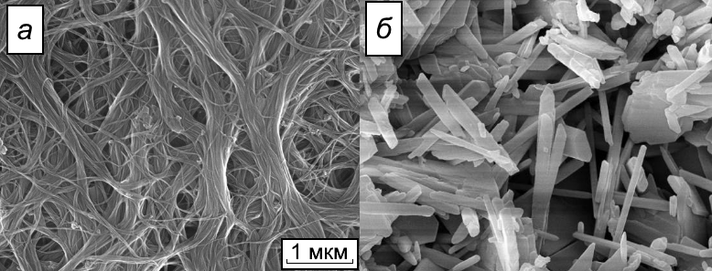
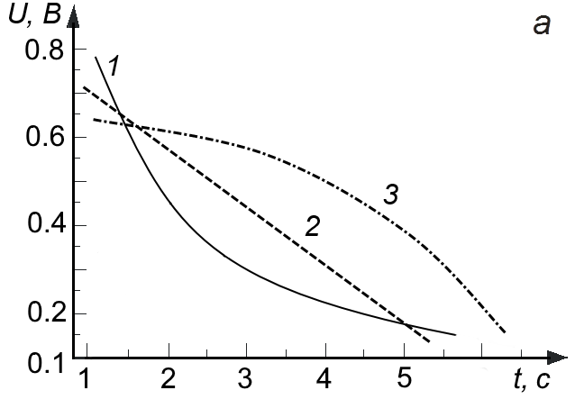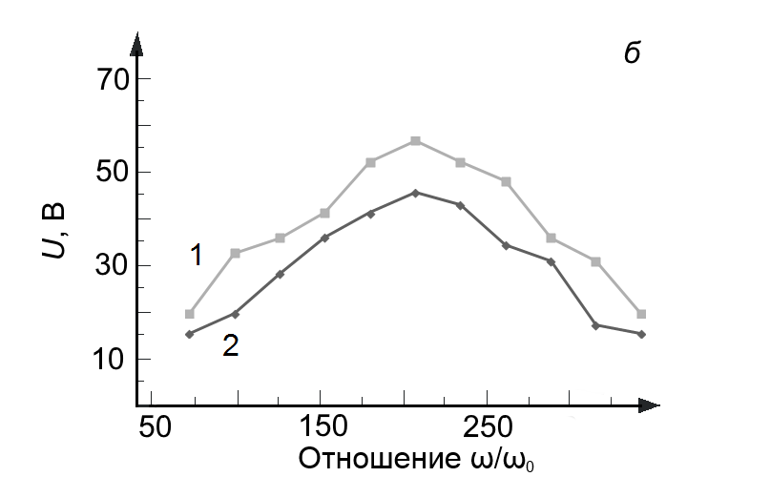
10. Samples of the references are available at http://conf-asu.ru/hpcst/
11. For the structure of the paper written in English, see the formatting sample, available at http://conf-asu.ru/hpcst/.

